**Training and Attestation**

**Purpose**

The purpose of this document is to identify the training objectives completed, specific tasks completed, and attest that I completed the exercises utilizing my own understanding of the material.

**Exercise 2.9.2**

**Core**

1. Set up the network topology in physical mode.
   1. Place 2 switches on rack and 2 PCs on table.
   2. Connect the 2 switches together using proper cabling.
   3. Connect 1 PC to each switch.
2. Configure PC hosts.
   1. Set the IP addresses for each host.
   2. Ping hosts: PC1 to PC2 then PC2 to PC1.
3. Configure and verify basic switch settings.
   1. Connect console cable for administrative access to switch.
   2. Enter privileged exec mode.
   3. Change switches host name.
   4. Change local passwords.
   5. Configure and enable VLAN 1 interface.
   6. Create login banner.
   7. Save the configuration.
   8. Display IOS and other switch information.
   9. Display status of connected interfaces.

**Screenshots of Completion**

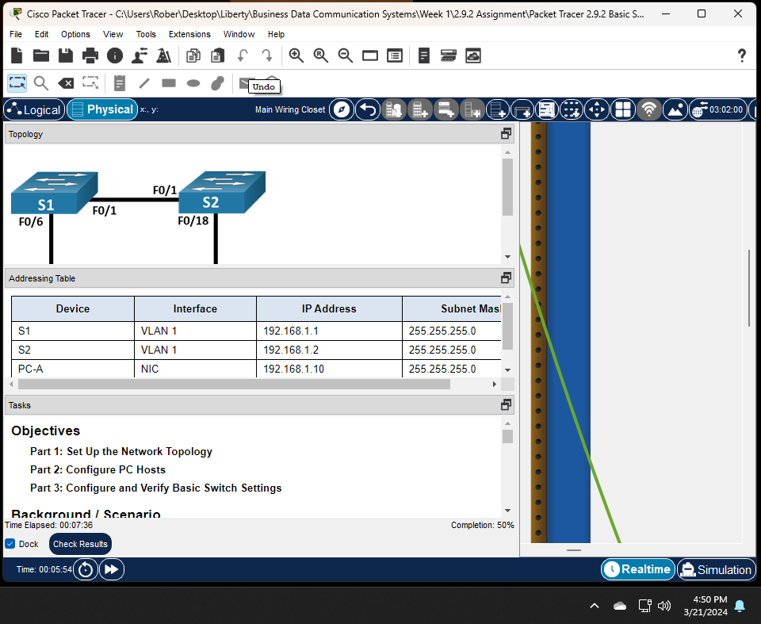

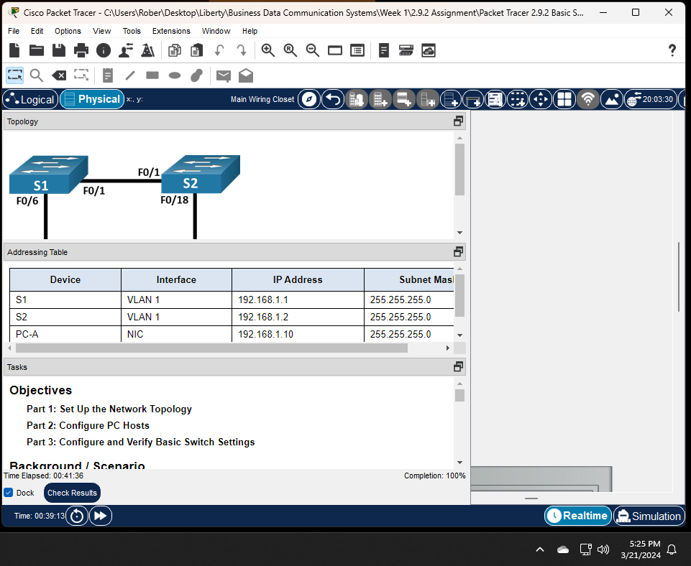

**Attestation**

I certify that I completed all the work required for this lab using the skills and knowledge gained from completing the Liberty University course work and Official Cisco CCNA training material. The answers were my own and I did not plagiarize anyone else’s work.

